**Kol simcha torah gazette**

**For parshas tetzaveh 5784**

Volume 8 Issue 24 (Whole #382) 15 Adar Rishon 5784/ February 24, 2023

**Printed L’illuy nishmas Nechama bas R’ Noach, a”h**

For a free subscription, please forward your request to [***keren18@juno.com***](mailto:keren18@juno.com)

***Past emails can be found on the website ShabbosStories.com under Brooklyn Torah Gazette***

**Rav Avigdor Miller on**

**What is the Purpose**

**Of Reciting Tehillim**

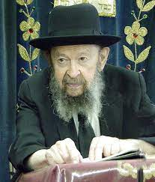

Yeshiva people, you know, say Tehillim. It’s a remarkable thing, how much the yeshivos pray for people. And the purpose is twofold. One is to demonstrate that we have complete trust in Hakodosh Boruch Hu that He is the only one who is in charge of our fate. By addressing ourselves to Him in time of our need or somebody else’s need, it creates such a great merit that Hakodosh Boruch Hu says, “In the merit of emunah and bitachon, I’m going to grant your request and show you – I’ll demonstrate that your trust is justified.”

There’s another thing. When we repeat the beautiful, inspired songs of Dovid, you just cannot help but be changed by that; because you are walking in his footsteps, in the footsteps of his thoughts, some of these thoughts will take hold of your mind and transform you in the course of time. And that’s a very great benefit.

That’s why we are always busy repeating the words of Tehillim in our prayers. Ashrei, the lyric of Dovid, is one of the greatest poems ever written in the history of mankind and inspired by a ruach from above. And the Mesillas Yesharim says that repeating those words, walking in the footsteps of Dovid, encourages us in the ways of love of Hashem and true chassidus.

And in the merit of these two things – number one demonstrating that Hashem is our trust, and number two by studying the ideas and the attitudes of Dovid our great teacher, Hakodosh Boruch Hu listens to our prayers and rewards us.

*Reprinted from the Parshas Terumah 5784 email of Toras Avigdor, based on the teachings of Rav Avigdor Miller, zt”l. Adapted from Tape #443 (January 1983).*

**Thoughts that Count**

**For Our Parsha**

*And you shall command (teztave) the Children of Israel* (Ex. 27:20)

The Hebrew word "tetzaveh" is related to "tzavta," which means connection or bond. In other words, G-d commanded Moses to be always connected to the Jewish people. Because Moses was dedicated to the Jews to the point of mesirat nefesh (giving up one's soul), he merited that his strength would remain with them forever. (Sefat Emet)

*To cause a lamp to burn continuously...outside the veil* (Ex. 27:20-21)

The Divine light within every Jew must illuminate at all times, not only in the "Tent of Meeting," the synagogue or the study hall, and not only when he prays and studies Torah. Rather, the intention is to cause G-d's light to shine even "outside the veil" - in the street, in one's day-to-day affairs, and in all of one's social interactions. (Yalkut Eliezer)

*And that the breastplate not be loosened from the Ephod* (Ex. 28:28)

The breastplate was worn on the chest of the High Priest over his heart. The numerical equivalent of "Ephod" is 85, the same as the word "peh," meaning mouth. In commanding that the breastplate, symbolic of the heart, not be loosened from the ephod, symbolizing the mouth, the Torah is giving us a hint that a person's heart and mouth should always be in sync with each other. *(Degel Machane Efraim)*

*Reprinted from the Parshat Tetzave 5761/2001 edition of L’Chaim Weekly.*

**The Jews are Compared**

**To a “Menora all of Gold”**

**From the Teachings of the Lubavitcher Rebbe**

**Rabbi Menachem Mendel Schneerson, Zt”l**

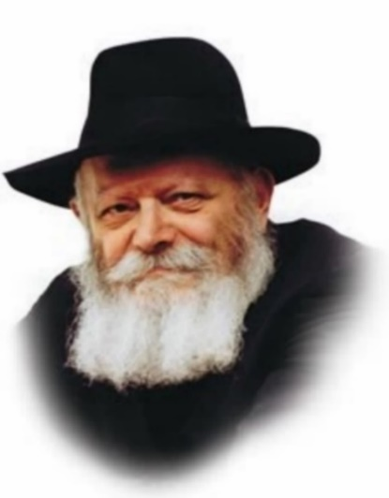

As related in this week's Torah portion of Tetzave, there were two steps involved in lighting the menora (seven-branched candelabra) in the Sanctuary. The first requirement was that the oil had to be brought to Moses: "And they shall take to you pure olive oil...for the lamp to burn always." The second consisted of Aaron the High Priest actually kindling the menora: "Aaron and his sons shall set it in order [to burn] from evening till morning."

**Two Questions**

This raises two questions: Why did the oil have to be brought to Moses, if Aaron was to light the menora? Secondly, why does the Torah refer to a lamp that burns "always" regarding Moses, whereas regarding Aaron it states "from evening till morning"?

To explain: The menora in the Holy Temple is symbolic of the Jewish people. In the prophecy of Zechariah the Jews are likened to "a menora all of gold." Every individual Jew is a "candle," as it states, "The soul of man is the candle of the L-rd." The function of Aaron is to "kindle the lamps" - to ignite the Jewish soul by revealing its innate, fiery desire to cleave to G-d.

This "fire" is lit by the Torah and its commandments. In general, there are two aspects to our service of G-d: the study of Torah, and prayer. (The performance of mitzvot is included in the latter.) A fire can burn steadily - "always" - or it can vary in intensity, growing brighter or dimmer - "from evening till morning." In the service of G-d, the Torah is the flame that burns "always," whereas prayer and the performance of mitzvot are dependent on time, place and circumstances.

**The Perpetual Mitzvah**

The Torah is completely above time and place. It is G-d's word and wisdom. The obligation to learn Torah is a perpetual mitzva, and applies day and night. The Torah is therefore called "a lamp that burns always."

By contrast, prayer has a specific, set time: morning (Shacharit), afternoon (Mincha), and evening (Maariv). The performance of mitzvot also varies, as some mitzvot can only be done at set times and only if specific criteria are met. For this reason, prayer and mitzvot are likened to a lamp that burns "from evening till morning."

This also helps explain the difference between Moses and Aaron. The essence of Moses is the Torah, which is why it is called "the Torah of Moses." Moses is thus associated with a perpetual light that "burns always." Aaron, however, symbolizes the service of the sacrifices in the Holy Temple, for which nowadays, prayer is substituted. Aaron is thus associated with a lamp that burns "from evening till morning."

**The Individual “Fire” Within Every Jew**

The requirement to first bring the oil to Moses imbued Aaron with the eternal power of the Torah. Its transcendent aspect could then be brought down into the limitations of time and place, to be carried out by means of Torah and mitzvot. The individual "fire" within every Jew could thus also illuminate with a steady and perpetual flame.

*Reprinted from the Parshat Tetzave 5761/2001 edition of L’Chaim Weekly. Adapted from Sefer HaSichot 5740, vol 1.*

**Rabbi Berel Wein on**

**Parshat Tetzaveh 5784**

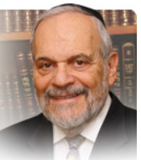

If clothes make the man, the garments of the ordinary priests and the High Priest of Israel certainly grant them the authority and holiness of their offices. One of the major disqualifications that affected the priest’s ability to perform services in the Temple was that he lacked the proper clothing that characterized and identified him. We find generally in Jewish life that clothing plays an important societal and religious role.

Modesty in dress, special clothing for the Sabbath and holidays and acceptable attire have always been the norms in Jewish society. The clothing of Jews was always affected by the influence of the countries and societies in which they lived. One need only look at the paintings of the Dutch masters of the seventeenth century, portraying the Jews and rabbis of Amsterdam at their synagogue services and homes, in order to realize how acculturated Jewish dress was, even amongst the most rigorously pious rabbis of the time.

The Church sought to regulate the colors of dress that Jews would be allowed to wear in the Middle Ages. It was the Church that made black the main color motif of Jewish dress. It seems that the Jews in Europe before the time of the Crusades wore brightly colored clothing as did their non-Jewish neighbors. It was only after the official medieval persecution of Ashkenazic Jews by the Church that restrictions were made on the color and type of clothing that could be worn by Jews.

Jews were also forced to wear ludicrous looking hats and badges of shame on their clothing. However, Jews made their forced shameful clothing items of Jewish pride and long after the decline of the Church and the abolition of such degrees (though they were restored by the Germans in World War II) Jews continued to wear informal peasant dress, strange hats and caps and mainly black clothing. The rule regarding all clothing was that it be modest and presentable.

The garments of the High Priest of Israel were ornate, unique and very luxurious in manufacture and appearance. In contrast, the garments of the ordinary priests of Israel were simple, sparse and sparkling white. If the garments of the High Priest represented majesty, grandeur and power of leadership, the garments of the ordinary priests represented holiness and service.

Not everyone could aspire to achieve majesty and grandeur – there was only one High Priest present at any one given time during the periods of the First and Second Temples. However, purity of life and devotion to service of G-d and of Israel was something that many could achieve. This truth was reflected in the different clothing of the High Priest and of his fellow, but ordinary, priests.

It is to be noted that the High Priest himself also always wore the vestments of the ordinary priests. He had four additional garments that he wore that were of precious metal and fabric and unique to him. But before one could don the garments of majesty, power, grandeur and importance, one had to first learn the lessons of humility, holiness, purity and service to others and to G-d as represented by the clothing of the ordinary priests of Israel. Though we no longer have priestly vestments present in our Jewish society today, the lessons that they taught us should be remembered and followed.

Shabbat shalom

*Reprinted from the current website of rabbiwein.com*

**Honey**

**By Rabbi Hillel Raskin**



**Rabbi Hillel Raskin**

Is “honeydew honey” kosher since the bees eat bug excretions?

The Gemara teaches that although what emerges from a non-kosher animal is not kosher, honey is nonetheless kosher.



There are two explanations given for this:

(1) Unlike milk, honey originates from nectar and isn’t a product of the bee itself. The little bit of bee saliva is batel in the rest.

(2) There is a gezeiras hakasuv, a derivation from the posuk (Vayikra 11:21), “Ach es zeh,” teaching that this type of emission is allowed.

Although honey, on its own, is a kosher product, honey still requires a proper hechsher, whether due to additives or unkosher machinery, unless it’s 100% pure and not heated at all. Honey is the third most counterfeited food (after milk and olive oil). Corn syrup, sometimes used to dilute the honey due to its lower price, is an issue of kitniyos for Pesach.

**Nosen Taam Lifgam**

During the processing of honey, it is heated to filter out bee particles (i.e., legs). This doesn’t pose a problem since their flavor in honey is unsavory (“nosen taam lifgam”) and does not prohibit the mixture.

Moreover, even if some bee legs remain in the honey, it would be kosher b’dieved since they are “dry bones” and not flesh. Yet, they should be removed.

“Forest honey,” “Honeydew honey,” and honey named after various types of trees generally refer to honey produced by bees that have consumed the excretions of aphids and scale insects left on trees (unlike standard honey produced from flower nectar).

**The Question of Aphids**

If the allowance for honey is derived from a special posuk, it only applies to the secretion of bees and not the secretion of aphids. Some suggest that the aphid secretion isn’t edible until the bee transforms it into honey. But in practice, these other honeys are considered to originate from non-kosher sources.

The kashrus of honey from other types of hornets or wasps hinges on a disagreement among Rishonim. Shulchan Aruch brings both opinions, with preference implied for the lenient view.

But the Rama implies that one should act stringently if these honeys were to be found.

*Reprinted from the Parshat Terumah 5784 edition of The Weekly Farbrengen. Rabbi Raskin is Rov of Anash in Petach Tikva, Israel.*

**The Urim and the Tumim (28:30)**

The stones of the breastplate were engraved with the names of the Twelve Tribes. When the High Priest asked a question by means of the Urim and Tumim, individual letters on the stones were illuminated; to derive the answer, the letters had to be put in the proper order. However, in order to know how to arrange them correctly, the High Priest had to be Divinely inspired, which was arrived at by concentrating on the word "Tumim." *(Ramban)*

*Reprinted from the Parshat Tetzave 5761/2001 edition of L’Chaim Weekly.*

**My Husband Gave His Life in Gaza for the Jewish People**

***An interview with Hadas Lowenstern,***

***wife of fallen soldier Elisha***

**By**[**Rachel Trilokekar**](https://www.chabad.org/search/keyword_cdo/kid/16945/jewish/Trilokekar-Rachel.htm)

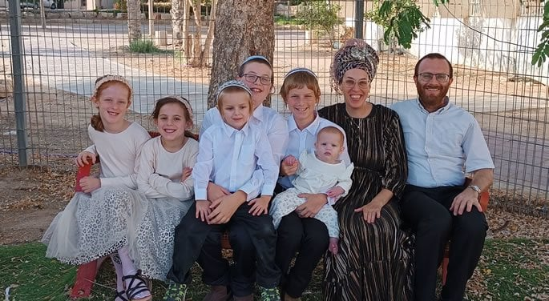

“He was the love of my life,” said Hadas Loewenstern in a now-viral video tribute about her beloved husband, Elisha Loewenstern (*z”l*), who died heroically at 38 defending Israel in Gaza.

Elisha had been on his way to rescue soldiers wounded in battle when an anti-tank missile fired by Hamas killed him. In addition to his wife, Elisha leaves behind 6 children—the youngest is 11 months and the oldest is 12, preparing for his bar mitzvah later in the year.

What makes this story even more extraordinary is that Elisha was exempt from serving because of their family size. However, [Hadas](https://www.chabad.org/library/article_cdo/aid/998913/jewish/How-to-Select-the-Best-Lulav-and-Etrog.htm) and Elisha felt a sense of duty to contribute. Elisha enlisted to fight, and Hadas cared for their children at home.

When Hadas speaks, you can’t help but be drawn to her. She expresses herself with a mix of humility and conviction that has the power to inspire and transform.

In a video interview, the deep bond that Hadas and Elisha share is palpable.

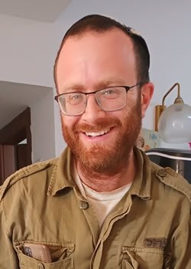

**Elisha Loewenstern, z”l**

Hamas seeks to destroy families, kill innocents, and separate loved ones by taking hostages. Rather than falling into despair, we have an opportunity to do the exact opposite–by strengthening ourselves and fortifying our marital bonds and relationships. Hadas consistently conveyed this message, and it made me wonder how we might emulate the unity she and her husband so effectively achieved.

Hadas was happy to share with me. She emphasized that she and her husband were actually very different. She is outgoing and upfront, while he was shy and soft-spoken. Their backgrounds differed as well: He was born in New York and made Aliya to Israel with his family at the age of 8, whereas Hadas is a native Israeli. He grew up observant of Torah, while she only became observant at the age of 24.

Regardless of their differences, Hadas recognized early on that Elisha was right for her. “I saw that he was a righteous man. He was an *ish emet*, a ‘man of truth’. I admired and respected him so much for this.” Hadas spoke about his impeccable character attributes; he was kind-hearted, purpose-driven, attentive to detail and a good listener. He was also a man of integrity with a steadfast commitment to G‑d.

She went on to say, “As different as we were, we got along well. We both thought how amazing it would be to have all of these different characteristics in our home. We really felt that our differences, even though they weren’t easy, enriched us.”

However, at the heart of their core values, Hadas and Elisha were in complete alignment.

The first of their deeply shared values was their zeal in the creation of a home where [Torah](https://www.chabad.org/library/article_cdo/aid/1426382/jewish/Torah.htm) is the focal point of their household.

**A Priority to Benefit from Older, Wiser Mentors**

Elisha, a successful software engineer, was also an ordained rabbi and an advanced Torah scholar. He was committed to learning the Daily Rambam and was known as a pillar of the community in Harish, where he taught extensively. He internalized his Torah study, developing not only his knowledge but his character. He also made it a priority to have older, wiser mentors that he could learn from and emulate. Hadas mentioned that Rav Eliyahu Blumenzweig, the Rosh Yeshiva of Yerucham, profoundly influenced Elisha and played a significant role in the growth of his spiritual world.

Like her husband, Hadas is a truth seeker. In a video interview, Hadas mentioned that while serving in the IDF she had a pivotal encounter with a soldier who was a religious Jew. She found herself compelled to ask herself serious questions, such as, “Who am I? Why do I live in Israel? Why do our enemies hate us so much? What is so unique about the Jewish nation? Why are we different from all other nations?” The answers she discovered were so impactful that she felt an undeniable pull to learn more and dedicate herself to a life of Torah.

**A Deeply Ingrained Sense of Gratitude**

During the interview, a wave of emotion occasionally overcame Hadas as she spoke about Elisha. “I knew from the beginning how special he was, and I always knew it throughout our marriage,” she reflected. These words of appreciation emphasize another core value shared by Elisha and Hadas: a deeply ingrained sense of gratitude. “I’m the only woman in the world who had the *privilege* of marrying Elisha,” Hadas says.

“Every night before we went to bed, we would say to each other, 'Thank you for marrying me. I love you. I appreciate you.’ It may not seem like much, but when you do it every day, it becomes very significant,” Hadas shared. They welcomed 3 children in 4 years, followed by 3 more. "Of course, I still face challenges, but I am so thankful for what I have,” she acknowledges. “I have 6 Elishas.”

Her husband enjoyed showing his appreciation for Hadas. He made it a tradition to buy her a gift for every Rosh Chodesh (new Hebrew month). This tradition continued even after his passing. Last Rosh Chodesh, after her husband had already been killed, Hadas received an unexpected visit from a stranger who delivered a necklace to her. Hadas instantly knew that it was a gift from Elisha, sent straight from heaven. “Who else sends his wife presents from Heaven?!” she exclaimed.

**“How Will it Benefit the Jewish Nation”**

One might think Hadas would regret their decision for her husband to enlist, but she says they harbored no doubts because the decision was rooted in the mindset that they—*as a unit*—had a mission: Every decision was about “How will it benefit the Jewish nation?” rather than “How will it affect us?”

To Hadas, this perspective represents the Jewish way of life. She explains, “When a non-Jewish couple gets married, they face each other during the wedding ceremony and afterward, they often enjoy a honeymoon alone. In contrast, when a Jewish couple stands under the chuppah, they are facing Am Yisrael. Immediately after the ceremony, they are embraced by the community for seven days of unified celebration.

When Elisha was permitted to briefly return home from the war to spend Shabbat with his family, they both felt compelled to invite guests for Shabbat instead of preferring time as a family alone. For the Loewenstern family, “To be normal is to be on the giving side.”

Though Elisha is no longer with them, Hadas wants her and the children to continue being a happy, giving family. She acknowledges her vulnerability without Elisha and recognizes her current need for support from others. Yet, she is determined for her family not to be perceived as needy and to always continue thinking of others.

**Her Message to the Jewish Nation**

At the conclusion of our interview, I asked Hadas what final message she wanted to impart to the Jewish nation. She answered:

“Just to know that even through all the difficulties of this generation, we are immensely privileged to live in this era—the one that will, [G‑d](https://www.chabad.org/library/article_cdo/aid/433240/jewish/God.htm) willing, witness the coming of the Moschiach. This is something to be so grateful for.”

Listening to Hadas, it’s clear that strength in the face of adversity stems from actualizing our unique mission and purpose, while cultivating a deep sense of gratitude for all that we have. This is how we can cultivate trust in G‑d, knowing we are here for a reason.

As Hadas so eloquently reminds us, “It’s not about when you die, but how you lived. And though Elisha died once, he lived every single day of his life.”

We can do the same. We can choose to act with confident conviction in who we are and what we have to give, forging a legacy of unity and resilience that not only inspires, but transforms—for generations to come.

*Reprinted from the current website of Chabad.Org*

**Rav Yosef Yitzchak Schneersohn of Lubavitch**

**By Tzivia Meth**

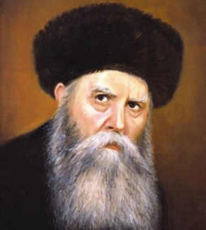

**Soviet Union, 1918**

The Bolsheviks despised religion — the “opium of the masses,” as they called it — and insisted it be stamped out at all costs. But they also despised the czars, and persecuting Jews mirrored the behavior of the czars — which they wanted to avoid at all costs.

Their solution: Jewish Communists, who could not be accused of anti-Semitism, would stamp out Judaism for them. The ”Yevsektsia,” as these Jewish Communists were called, surpassed the Soviet government’s best hopes. They attempted to crush all vestiges of traditional Judaism, even those the Communist government had declared legal.

And of all forms of Jewish traditional practice, the Yevsektsia had a particular antipathy for Torah study. While most yeshivos, seeing the utter impossibility of further Torah growth in the USSR, fled across the border to Poland, one network of yeshivos became famous for its heroic refusal to leave:

Lubavitch, under the leadership of Rav Yosef Yitzchak Schneerson, the sixth Lubavitcher Rebbe (also known as the Rebbe Rayatz). The Rebbe is said to have once told a czarist police officer, “The Schneersons don’t run away!”. Upholding that maxim, the Rebbe organized a massive network of underground yeshivos throughout the USSR — around 600 schools, according to one biographer.

The Rebbe knew that in the trying times to come, he and his followers would need the utmost dedication for their mission to succeed. In a secret ceremony in 1922, he gathered a select group of students, urging them to continue the battle for Torah:

“I took eight youngsters who were strong in both body and spirit, and we gathered together in Moscow. There we made a solemn oath: come what may, to persist in our mission, to the very last drop of our blood.”

**How Did the Rebbe and His Followers Succeed?**

But in the secret police state that was the Soviet Union, blood was shed to the last drop quickly and frequently. How did the Rebbe and his followers succeed in organizing so many underground yeshivos in such circumstances?

“Child guards were placed right outside the doors where learning was taking place, just like in the days of the Spanish Inquisition,” Chabad historian Rabbi Shalom DovBer Levine wrote of the time. “If anyone unfamiliar chanced by, the signal was given: Hide the seforim and stop learning immediately.”

In Novgorod, Rav Chaim Shaul Bruk, a renowned Chabad mashpia in Russia, led an underground yeshivah in a shul attic. Even though it was stiflingly hot, he taught classes there for hours at a stretch, imbued with the Rebbe’s resolve. And to keep away unwanted visitors, Rav Bruk devised a special code: the bochurim would knock in a prearranged sequence when it was safe to enter and exit the hideaway.

But the attic soon came under suspicion, and Rav Bruk hastily moved the yeshivah to the shul chazzan’s home. It would have been the perfect hideout — except that the chazzan’s son, as it turned out, was a Communist. But Rav Bruk knew that there were two kinds of Communists: the ideological ones, who wouldn’t take bribes, and the opportunistic ones, who would. What type was the chazzan’s son?

**Yeshiva Bochurim Were Frequently Dragged to Jail and Beaten**

Fortunately, for the right price, the chazzan’s son was willing to look the other way so that the yeshivah could continue its activities. But despite the precautions that Chabad leaders took, they faced enormous risks. Yeshivah bochurim were frequently dragged to jail and beaten.

In one instance, the Yevsektsia beat a boy suspected of learning in yeshivah, then stood him against a wall in the prison courtyard. A firing squad took aim, the officer gave the command, and rifle shots rang out — but the boy emerged unscathed. The officer had instructed his soldiers to fire just above the boy’s head as an intimidation tactic. The bochur was released, and went back to yeshivah — where he suffered a nervous breakdown due to the trauma he experienced.

After his release from prison, the Rebbe Rayatz arrives in America in 1929 on a goodwill tour. He would settle there permanently after fleeing Europe at the onset of World War II It was not only the threat of arrest and torture that yeshivah bochurim had to contend with. The young men were hounded relentlessly to give information on their classmates and rebbeim, so the Yevsektsia could build large case files for a mass arrest.

**“There was Something Suspicious about Him”**

Rav Nachum Shmarya Sassonkin, who learned in the Tiferes Bochurim yeshivah in Leningrad, recalled that one day, a boy from Minsk joined the underground beis medrash. He learned well, and joined the young men in all their activities. But Rav Sassonkin recalled that the boys felt “there was something suspicious about him.” Expelling him from the yeshivah could invite further trouble, so they decided to keep an eye on him.

On Yom Kippur, he cried harder than everyone else, and the bochurim wondered what terrible secret he was hiding. It became apparent all too soon. Unable to withstand the terrible pressure from the NKVD (the Soviet secret police, a predecessor to the KGB), he had informed on them — with dire consequences. Rav Sassoskin recounted:

First they imprisoned our maggid shiur, Rav Nachum Terebnik, and exiled him [to Siberia] for three years, in the hope that this would frighten the rest of us into submission. But when they saw that Torah study was continuing just as [it had] before, they decided to imprison all of us.

**They Were Never Heard from Again**

One evening the Agents of Destruction [i.e. the NKVD] came and imprisoned the whole group, among them my two sons, and they were sent to Siberia for ten years of exile. After enduring brutal conditions in the labor camps, where many perished from hunger and thirst, cold and frost, they were never heard from again.

The Yevsektsia, though, were not content with striking just individual bochurim and yeshivos; they really wanted the mastermind whose will and daring kept it all going. All the evidence — in particular, a voluminous paper trail of correspondence — pointed to the Rebbe Rayatz.

One morning, NKVD agents burst into the shul where he was davening with his chassidim, and demanded that he stop his illegal activities. The Rebbe refused to be cowed by their threats.

One agent aimed a gun at his head and said, “This little ‘toy’ has made many a man change his mind!” “No,” the Rebbe replied calmly. “This toy can intimidate only a man with many gods and one world. I, however, have one G-d and two worlds — This World and the Next — so I am not impressed by your little toy.”

When continual threats did not succeed in stopping the Rebbe, the Yevsektsia pushed for more drastic measures. Early in the morning on June 15, 1927, NKVD agents, accompanied by Yevsektsia members, arrested the Rebbe in Leningrad. Taken to the infamous Spalerka Prison, he was tortured there for days, and sentenced to death.

Even in prison, the Rebbe’s determination for Torah did not waver. Without paper or seforim, he scribbled Torah thoughts on cigarette papers, and when he was told he could not have his tefillin, he went on a hunger strike for two and a half days until they were — remarkably — returned to him.

Eventually, a bevy of highly placed and prominent figures — including Chief Rabbi of Yerushalayim Rav Avraham Yitzchak Kook, US Supreme Court Justice Louis Brandeis, Senator William Borah of Idaho, and even President Calvin Coolidge — pushed for his release.

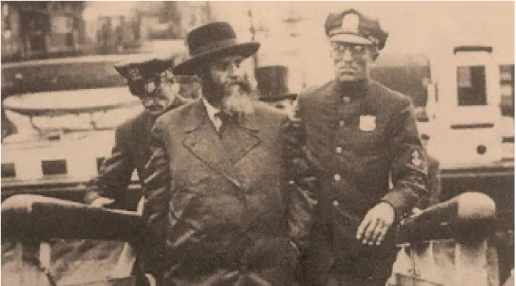

**After his release from prison, the Rebbe Rayatz arrives in America in 1929 on a goodwill tour. He would settle there permanently after fleeing Europe at the onset of World War II**

Due to their efforts, the Rebbe’s sentence was commuted to forced exile. He continued his work on behalf of Soviet Jewry from his new home in Riga, Latvia, and later Warsaw, Poland, until the outbreak of World War II led him to American shores. (Mishpacha Magazine September 12 2023)

*Reprinted from the current Parashat Tetzave 5784 parsha sheet whY I Matter edited by Yedidye Hirtenfeld for the Young Israel of Midwood in Brooklyn.*